**COMPILER DESIGN LAB 9**

**Q1.** Modify the Recursive Descent parser implemented in the previous lab to parse

decision making and looping statements with error reporting.

PROGRAM:

#include <stdio.h>

#include <stdlib.h>

#include <ctype.h>

#include <string.h>

#include "lex.c"

void program();

void declarations();

void datatype();

void idlist();

void idlistprime();

void assignstat();

void statementlist();

void statement();

void expn();

void eprime();

void simpleexp();

void seprime();

void term();

void tprime();

void factor();

void decisionstat();

void dprime();

void loopingstat();

void relop();

void addop();

void mulop();

struct token tkn;

FILE *f1;

char *rel[]={"==","!=","<=",">=",">","<"};

char *add[]={"+","-"};

char *mul[]={"*","/","%"};

int isrel(char *w)

{

int i;

for(i=0;i<sizeof(rel)/sizeof(char*);i++)

{

if(strcmp(w,rel[i])==0)

{

return 1;

}

}

return 0;

}

int isadd(char *w)

{

int i;

for(i=0;i<sizeof(add)/sizeof(char*);i++)

{

if(strcmp(w,add[i])==0)

{return 1;

}

}

return 0;

}

int ismul(char *w)

{

int i;

for(i=0;i<sizeof(mul)/sizeof(char*);i++)

{

if(strcmp(w,mul[i])==0)

{

return 1;

}

}

return 0;

}

void program()

{

if(strcmp(tkn.lexeme,"main")==0)

{

tkn=getNextToken(f1);

if(strcmp(tkn.lexeme,"(")==0)

{

tkn=getNextToken(f1);

if(strcmp(tkn.lexeme,")")==0)

{

tkn=getNextToken(f1);

if(strcmp(tkn.lexeme,"{")==0)

{

tkn=getNextToken(f1);

declarations();

statementlist();

if(strcmp(tkn.lexeme,"}")==0)

{

return;

}

else if(strcmp(tkn.lexeme,"for")==0 ||

strcmp("while",tkn.lexeme)==0)

{

loopingstat();

if(strcmp(tkn.lexeme,"}")==0)

{

return;exit(0);

}

else if(strcmp(tkn.lexeme,"for")==0 ||

strcmp("while",tkn.lexeme)==0)

{

loopingstat();

}

else if(strcmp(tkn.lexeme,"if")==0)

{

decisionstat();

}

else

{

printf("} missing at row=%d col=%d",tkn.row,tkn.col);

exit(1);

}

}

else if(strcmp(tkn.lexeme,"if")==0)

{

decisionstat();

if(strcmp(tkn.lexeme,"}")==0)

{

return;

}

else if(strcmp(tkn.lexeme,"for")==0 ||

strcmp("while",tkn.lexeme)==0)

{

loopingstat();

}

else if(strcmp(tkn.lexeme,"if")==0)

{

decisionstat();

}

else

{

printf("} missing at row=%d col=%d",tkn.row,tkn.col);

exit(1);

}

}

else

{

printf("} missing at row=%d col=%d",tkn.row,tkn.col);

exit(1);

}

}

else

{

printf("{ missing at row=%d col=%d",tkn.row,tkn.col);

exit(1);

}

}

else{

printf(") missing at row=%d col=%d",tkn.row,tkn.col);

exit(1);

}

}

else

{

printf("( missing at row=%d col=%d",tkn.row,tkn.col);

exit(1);

}

}

}

void declarations()

{

if(isdtype(tkn.lexeme)==0)

{

return;

}

datatype();

idlist();

if(strcmp(tkn.lexeme,";")==0)

{

tkn=getNextToken(f1);

declarations();

}

else

{

printf("; missing at row=%d col=%d",tkn.row,tkn.col);

exit(1);

}

}

void datatype()

{

if(strcmp(tkn.lexeme,"int")==0)

{

tkn=getNextToken(f1);

return;

}

else if(strcmp(tkn.lexeme,"char")==0)

{

tkn=getNextToken(f1);

return;

}

else

{

printf("%s Missing datatype at row=%d col=%d",tkn.lexeme, tkn.row,tkn.col);

exit(1);

}

}

void idlist()

{

if(strcmp(tkn.type,"IDENTIFIER")==0){

tkn=getNextToken(f1);

idlistprime();

}

else

{

printf("Missing IDENTIFIER at row=%d col=%d",tkn.row,tkn.col);

exit(1);

}

}

void idlistprime()

{

if(strcmp(tkn.lexeme,",")==0)

{

tkn=getNextToken(f1);

idlist();

}

if(strcmp(tkn.lexeme,"[")==0)

{

tkn=getNextToken(f1);

if(strcmp(tkn.type,"NUMBER")==0)

{

tkn=getNextToken(f1);

if(strcmp(tkn.lexeme,"]")==0)

{

tkn=getNextToken(f1);

if(strcmp(tkn.lexeme,",")==0)

{

tkn=getNextToken(f1);

idlist();

}

else

{

return;

}

}

else

{

printf("] missing at row=%d col=%d",tkn.row,tkn.col);

exit(1);

}

}

}

else

{

return;

}

}

void statementlist()

{

if(strcmp(tkn.type,"IDENTIFIER")!=0)

{return;

}

statement();

statementlist();

}

void statement()

{

if(strcmp(tkn.type,"IDENTIFIER")==0)

{

assignstat();

if(strcmp(tkn.lexeme,";")==0)

{

tkn=getNextToken(f1);

return;

}

else

{

printf("; missing at row=%d col=%d",tkn.row,tkn.col);

exit(1);

}

}

if(strcmp(tkn.lexeme,"if")==0)

{

decisionstat();

}

if(strcmp(tkn.lexeme,"while")==0 || strcmp(tkn.lexeme,"for")==0)

{

loopingstat();

}

}

void assignstat()

{

if(strcmp(tkn.type,"IDENTIFIER")==0)

{

tkn=getNextToken(f1);

if(strcmp(tkn.lexeme,"=")==0)

{

tkn=getNextToken(f1);

expn();

}

else

{

printf("= missing at row=%d col=%d",tkn.row,tkn.col);

exit(1);

}

}

else

{

printf("Missing IDENTIFIER at row=%d col=%d",tkn.row,tkn.col);

exit(1);

}

}void expn()

{

simpleexp();

eprime();

}

void eprime()

{

if(isrel(tkn.lexeme)==0)

{

return;

}

relop();

simpleexp();

}

void simpleexp()

{

term();

seprime();

}

void seprime()

{

if(isadd(tkn.lexeme)==0)

{

return;

}

addop();

term();

seprime();

}

void term()

{

factor();

tprime();

}

void tprime()

{

if(ismul(tkn.lexeme)==0)

{

return;

}

mulop();

factor();

tprime();

}

void factor()

{

if(strcmp(tkn.type,"IDENTIFIER")==0)

{

tkn=getNextToken(f1);

return;

}

else if(strcmp(tkn.type,"NUMBER")==0){

tkn=getNextToken(f1);

return;

}

}

void decisionstat()

{

if(strcmp(tkn.lexeme,"if")==0)

{

tkn=getNextToken(f1);

if(strcmp(tkn.lexeme,"(")==0)

{

tkn=getNextToken(f1);

expn();

if(strcmp(tkn.lexeme,")")==0)

{

tkn=getNextToken(f1);

if(strcmp(tkn.lexeme,"{")==0)

{

tkn=getNextToken(f1);

statementlist();

if(strcmp(tkn.lexeme,"}")==0)

{

tkn=getNextToken(f1);

dprime();

}

else

{

printf("} missing at row=%d col=%d",tkn.row,tkn.col);

exit(1);

}

}

else

{

printf("{} missing at row=%d col=%d",tkn.row,tkn.col);

exit(1);

}

}

else

{

printf(") missing at row=%d col=%d",tkn.row,tkn.col);

exit(1);

}

}

else

{

printf("( missing at row=%d col=%d",tkn.row,tkn.col);

exit(1);

}

}

}

void dprime(){

if(strcmp(tkn.lexeme,"else")==0)

{

tkn=getNextToken(f1);

if(strcmp(tkn.lexeme,"{")==0)

{

tkn=getNextToken(f1);

statementlist();

if(strcmp(tkn.lexeme,"}")==0)

{

tkn=getNextToken(f1);

return;

}

else

{

printf("} missing at row=%d col=%d",tkn.row,tkn.col);

exit(1);

}

}

else

{

printf("{ missing at row=%d col=%d",tkn.row,tkn.col);

exit(1);

}

}

else

{

return;

}

}

void loopingstat()

{

if(strcmp(tkn.lexeme,"while")==0)

{

tkn=getNextToken(f1);

if(strcmp(tkn.lexeme,"(")==0)

{

tkn=getNextToken(f1);

expn();

if(strcmp(tkn.lexeme,")")==0)

{

tkn=getNextToken(f1);

if(strcmp(tkn.lexeme,"{")==0)

{

tkn=getNextToken(f1);

statementlist();

if(strcmp(tkn.lexeme,"}")==0)

{

tkn=getNextToken(f1);

return;

}

else{

printf("} missing at row=%d col=%d",tkn.row,tkn.col);

exit(1);

}

}

else

{

printf("{ missing at row=%d col=%d",tkn.row,tkn.col);

exit(1);

}

}

else

{

printf(") missing at row=%d col=%d",tkn.row,tkn.col);

exit(1);

}

}

else

{

printf("( missing at row=%d col=%d",tkn.row,tkn.col);

exit(1);

}

}

else if(strcmp(tkn.lexeme,"for")==0)

{

tkn=getNextToken(f1);

if(strcmp(tkn.lexeme,"(")==0)

{

tkn=getNextToken(f1);

assignstat();

if(strcmp(tkn.lexeme,";")==0)

{

tkn=getNextToken(f1);

expn();

if(strcmp(tkn.lexeme,";")==0)

{

tkn=getNextToken(f1);

assignstat();

if(strcmp(tkn.lexeme,")")==0)

{

tkn=getNextToken(f1);

if(strcmp(tkn.lexeme,"{")==0)

{

tkn=getNextToken(f1);

statementlist();

if(strcmp(tkn.lexeme,"}")==0)

{

tkn=getNextToken(f1);

return;

}

else

{

printf(" } missing at row=%d col=%d ",tkn.row,tkn.col);

exit(1);

}

}

else

{

printf("{ missing at row=%d col=%d ",tkn.row,tkn.col);

exit(1);

}

}

else

{

printf(") missing at row=%d col=%d",tkn.row,tkn.col);

exit(1);

}

}

else

{

printf("; missing at row=%d col=%d",tkn.row,tkn.col);

exit(1);

}

}

else

{

printf("; missing at row=%d col=%d",tkn.row,tkn.col);

exit(1);

}

}

else

{

printf("( missing at row=%d col=%d",tkn.row,tkn.col);

exit(1);

}

}

}

void relop()

{

if(strcmp(tkn.lexeme,"==")==0)

{

tkn=getNextToken(f1);

return;

}

if(strcmp(tkn.lexeme,"!=")==0)

{

tkn=getNextToken(f1);

return;

}

if(strcmp(tkn.lexeme,"<=")==0)

{

tkn=getNextToken(f1);return;

}

if(strcmp(tkn.lexeme,">=")==0)

{

tkn=getNextToken(f1);

return;

}

if(strcmp(tkn.lexeme,"<")==0)

{

tkn=getNextToken(f1);

return;

}

if(strcmp(tkn.lexeme,">")==0)

{

tkn=getNextToken(f1);

return;

}

}

void addop()

{

if(strcmp(tkn.lexeme,"+")==0)

{

tkn=getNextToken(f1);

return;

}

if(strcmp(tkn.lexeme,"-")==0)

{

tkn=getNextToken(f1);

return;

}

}

void mulop()

{

if(strcmp(tkn.lexeme,"*")==0)

{

tkn=getNextToken(f1);

return;

}

if(strcmp(tkn.lexeme,"/")==0)

{

tkn=getNextToken(f1);

return;

}

if(strcmp(tkn.lexeme,"*")==0)

{

tkn=getNextToken(f1);

return;

}

}

int main()

{

FILE *fa, *fb;

int ca, cb;

fa = fopen("inp_71.c", "r");

if (fa == NULL){

printf("Cannot open file \n");

exit(0);

}

fb = fopen("output.c", "w+");

ca = getc(fa);

while (ca != EOF){

if(ca==' ')

{

putc(ca,fb);

while(ca==' ')

ca = getc(fa);

}

if (ca=='/')

{

cb = getc(fa);

if (cb == '/')

{

while(ca != '\n')

ca = getc(fa);

}

else if (cb == '*')

{

do

{

while(ca != '*')

ca = getc(fa);

ca = getc(fa);

} while (ca != '/');}

else{

putc(ca,fb);

putc(cb,fb);

}

}

else putc(ca,fb);

ca = getc(fa);

}

fclose(fa);

fclose(fb);

fa = fopen("output.c", "r");

if(fa == NULL){

printf("Cannot open file");

return 0;

}

fb = fopen("temp.c", "w+");

ca = getc(fa);

while (ca != EOF)

{

if(ca=='"')

{

putc(ca,fb);

ca=getc(fa);

while(ca!='"')

{

putc(ca,fb);

ca=getc(fa);

}

}

else if(ca=='#')

{

while(ca!='\n')

{

ca=getc(fa);

}

ca=getc(fa);

}

putc(ca,fb);

ca = getc(fa);

}

fclose(fa);

fclose(fb);

fa = fopen("temp.c", "r");

fb = fopen("output.c", "w");

ca = getc(fa);

while(ca != EOF){

putc(ca, fb);ca = getc(fa);

}

fclose(fa);

fclose(fb);

remove("temp.c");

f1=fopen("output.c","r");

if(f1==NULL)

{

printf("Error! File cannot be opened!\n");

return 0;

}

while((tkn=getNextToken(f1)).row!=-1)

{

if(strcmp(tkn.lexeme,"main")==0)

{

program();

break;

}

}

printf("Compiled sucessfully\n");

fclose(f1);

}

OUTPUT:

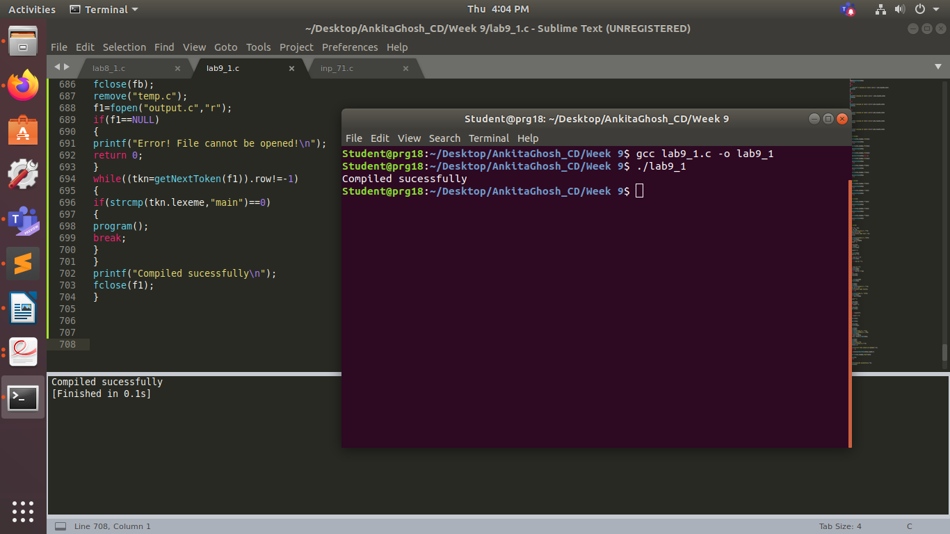

Sample Input:

main()

{

int arr[20],a,b,sum;

a=5;

b=1;

if(a==5)

{sum=a+b; }

}